New Center for Psychoanalysis, Los Angeles

Ofra Eshel:

﻿The Never-Ending Challenge of Reinventing Psychoanalysis for the Unknown

Saturday, March 29 from 9:00 am to 1:00 pm PST
Sunday, March 30 from 9:00 am to 1:30 pm PST
via Zoom

Pre-registration is required
8 CE credits
General registration $175 | Candidates and students $90
NCP Member Registration $140
International registration $50 USD

The Never-Ending Challenge of Reinventing Psychoanalysis for the Unknown

During this two-day conference, Ofra Eshel will present new work, which will be evaluated and discussed by contemporaries Charles Levin, Aner Govrin, and Mary Tennes, as well as a clinical case presentation by Margaret Rubin. The work focuses on recognition of the paradox of learning uncertainty as well as helping clinicians withstand the Unknown while building capacity to contain psychodynamic dislocation. The discussions of Dr. Eshel’s papers will focus on the fundamentals and creativity of her psychoanalytic work. Dr. Eshel draws deeply on the analytic tradition, particularly Winnicott and Bion; but also on how she helps us to think beyond them.

Register

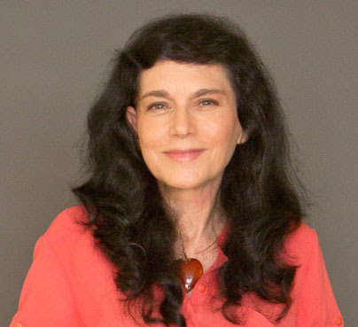

Ofra Eshel, PsyD, is a training and supervising analyst and senior faculty member of the Israel Psychoanalytic Society and Institute; fellow, the International psychoanalytic Association (IPA); Honorary Member of the New Center for Psychoanalysis, Los Angeles, and former vice-president of the International Winnicott Association (IWA). Founder and head of the post-graduate program “Winnicott, Bion, and Independent Psychoanalysis: Radical Breakthroughs” at the advanced studies of the Program of Psychoanalytic Psychotherapy, Faculty of Medicine, Tel-Aviv University. Founder (in 2024) of the advanced program “Radical Breakthroughs in Contemporary Psychoanalysis” at Deepsprings, Beijing, China. A prolific writer, her papers have been published in psychoanalytic journals and book chapters, translated into ten languages, and presented at national and international conferences across four continents. In 2023 she was ranked as the first of the top 10 authors writing on Winnicott between 1978-2023. She is the author of The Emergence of Analytic Oneness: Into the Heart of Psychoanalysis (Routledge, 2019), with translations into Chinese (2024) and Brazilian-Portuguese (2025). She is in private practice in Tel Aviv, Israel.

Discussants:

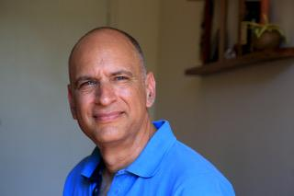Aner Govrin, PhD, is a clinical psychologist, philosopher, and psychoanalyst in private practice in Tel Aviv. He serves as director of the Psychoanalysis Hermeneutics doctoral program at Bar Ilan University’s Program for Hermeneutics and Culture. A training analyst at the Tel Aviv Institute of Contemporary Psychoanalysis (TAICP), he co-founded the School of Psychoanalytic Psychotherapy at the Tel Aviv Institute and was its first director. He is the editor of the Routledge Introductions to Contemporary Psychoanalysis book series. His recent book, How Philosophy Changed Psychoanalysis: From Naïve Realism to Postmodernism (Routledge, 2024), explores the intersection of philosophical thought and psychoanalytic theory. His forthcoming work, The Craft of Psychodynamic Case Study: Practical Guide, will also be published by Routledge.

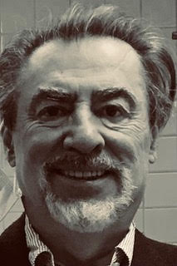

Charles Levin, PhD, FIPA, is a training and supervising analyst in private practice in Montreal. He has served over many years in a variety of capacities at the Canadian Psychoanalytic Society and Institute, including director of training and editor-in-chief of the Canadian Journal of Psychoanalysis. In addition to clinical psychoanalysis, his work focuses on issues related to culture, aesthetics, and psychoanalytic ethics. His publications include: The mind as an internal object, Psychoanalytic Quarterly (2010), Art in the Offertorium: Narcissism, Psychoanalysis and Cultural Metaphysics (Rodopi, 2012). He is currently completing a book-length study of Bion.

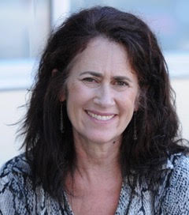

Mary Tennes, PhD, is a Training and Supervising analyst at the Psychoanalytic Institute of Northern California, where she is also faculty and the head of Faculty Development. In the last several decades, she has written and presented extensively on the intersection of psychoanalysis and the mystical, the telepathic and the uncanny. She is in private practice in Oakland, CA.

Clinical Presentation:  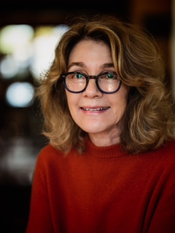 | Margaret Rubin, PhD, is a member and senior faculty at the New Center for Psychoanalysis (NCP). She has twice been awarded Faculty of the Year at NCP for teaching Relational Theory in the NCP training program. Her paper “Calamities and Secrets, The Power of the Fetish” is being published in the upcoming March/April Symposium Issue in Psychoanalytic Dialogues. She practices in Santa Monica.

Register

CONTINUING EDUCATION CREDIT

IMPORTANT DISCLOSURE INFORMATION FOR ALL LEARNERS: None of the planners and presenters for this educational activity have relevant financial relationship(s)* to disclose with ineligible companies* whose primary business is producing, marketing, selling, re-selling, or distributing healthcare products used by or on patients.
*Financial relationships are relevant if the educational content an individual can control is related to the business lines or products of the ineligible company.
-Updated July 2021-

PHYSICIANS: This activity has been planned and implemented in accordance with the accreditation requirements and policies of the Accreditation Council for Continuing Medical Education (ACCME) through the joint providership of American Psychoanalytic Association and The New Center for Psychoanalysis. The American Psychoanalytic Association is accredited by the ACCME to provide continuing medical education for physicians.
The American Psychoanalytic Association designates this Live Activity for a maximum of 3 AMA PRA Category 1 Credit(s)™. Physicians should claim only the credit commensurate with the extent of their participation in the activity.
PSYCHOLOGISTS: The New Center for Psychoanalysis is approved by the American Psychological Association to sponsor continuing education for psychologists. The New Center for Psychoanalysis maintains responsibility for this program and its content. Psychologists must report CE credits directly to MCEP using their attendance certificate to verify attendance. Please note that a Psychologist must attend the CE program in its entirety in order to receive credit.
SOCIAL WORKERS, MARRIAGE and FAMILY THERAPISTS (LCSW, LMFT, ASW, IMF, LEP, LPCC, PCCI): The New Center for Psychoanalysis is a continuing education provider that has been approved by the American Psychological Association, a California Board of Behavioral Sciences recognized approval agency.

New Center for Psychoanalysis
310.478.6541
info@n-c-p.org
n-c-p.org

New Center for Psychoanalysis | 2014 Sawtelle Blvd. | Los Angeles, CA 90025 US

