Health Monitoring Report in Accordance with FELASA Recommendations

Location: Felsenstein Medical Research Center Housing: Belinson Samples collection: 19/01/2025
Species: Mouse sentinel Strain: ICR females Date of report: 09/02/2025
Health report: 2 sentinel mouse – FELASA Annual. Samples: FEL-2 (room 2); FEL-4 (room 4).

 | Test  method |  | Latest  results | Historical  results
Viruses |  |  | Jan  2025 | Jul  2024 | Jan  2024 | Jul  2023 | Jan  2023 | Jul  2022 | Jan  2022 | Jul  2021
Mouse hepatitis virus (MHV) | IFA |  | 1/2 | 2/4 | 0/4 | 0/4 | 0/4 | 0/4 | 0/4 | 0/4
Mouse rotavirus (EDIM-ROTA-A) | MFI |  | 0/2 | 0/4 | 0/4 | 0/4 | 0/4 | 0/4 | 0/4 | 0/4
Minute virus of mice (MVM) | MFI |  | 0/2 | 0/4 | 0/4 | 0/4 | 0/4 | 0/4 | 0/4 | 0/4
Mouse parvovirus (MPV-1,-2,-5) | MFI |  | 0/2 | 0/4 | 0/4 | 0/4 | 0/4 | 0/4 | 0/4 | 0/4
Pneumonia virus of mice (PVM) | MFI |  | 0/2 | NT | 0/4 | NT | 0/4 | NT | 0/4 | NT
Sendai virus (SEND) | MFI |  | 0/2 | NT | 0/4 | NT | 0/4 | NT | 0/4 | NT
Theiler’s murine encephalomyelitis virus (TMEV-GDVII) | MFI,IFA |  | 0/2 | 0/4 | 0/4 | 0/4 | 0/4 | 0/4 | 0/4 | 0/4
Ectromelia virus (ECTRO) | MFI |  | 0/2 | NT | 0/4 | NT | 0/4 | NT | 0/4 | NT
Lymphocytic choriomeningitis virus (LCMV) | MFI |  | 0/2 | NT | 0/4 | NT | 0/4 | NT | 0/4 | NT
Mouse adenovirus type 1,2 (FL-MAV-1, K87-MAV-2) | MFI |  | 0/2 | NT | 0/4 | NT | 0/4 | NT | 0/4 | NT
Mouse cytomegalovirus (MCMV) | MFI |  | NT | NT | NT | NT | NT | NT | NT | NT
Reovirus type 3 (REO) | MFI |  | 0/2 | NT | 0/4 | NT | 0/4 | NT | 0/4 | NT
Generic parvovirus (NS-1) | MFI |  | 0/2 | 0/4 | 0/4 | 0/4 | 0/4 | 0/4 | 0/4 | 0/4
Murine norovirus (MNV) | MFI |  | NT* | NT | NT* | NT | NT | NT | NT* | NT
Bacteria, mycoplasma and fungi |  |  | Jan  2025 | Jul  2024 | Jan  2024 | Jul  2023 | Jan  2023 | Jul  2022 | Jan  2022 | Jul  2021
Mycoplasma pulmonis (MPUL)-Mouse | MFI |  | 0/2 | NT | 0/4 | NT | 0/4 | NT | 0/4 | NT
Bordetella bronchiseptica (Nasopharynx, lung) | CULT |  | 0/2 | 0/4 | 0/4 | 0/4 | 0/4 | 0/4 | 0/4 | 0/4
Citrobacter rodentium (Intestine, feces) | CULT |  | 0/2 | 0/4 | 0/4 | 0/4 | 0/4 | 0/4 | 0/4 | 0/4
Clostridium piliforme (CPIL, Tyzzer’s disease) | MFI |  | 0/2 | NT | 0/4 | NT | 0/4 | NT | 0/4 | NT
Corynebacterium kutcheri (Nasopharynx, lung, intestine) | CULT |  | 0/2 | 0/4 | 0/4 | 0/4 | 0/4 | 0/4 | 0/4 | 0/4
Klebsiella pneumoniae (Naso, lung) | CULT |  | 0/2 | 0/4 | 0/4 | 0/4 | 0/4 | 0/4 | 0/4 | 0/4
Klebsiella oxytoca (Intestine, feces) | CULT |  | 0/2 | 0/4 | 0/4 | 0/4 | 0/4 | 0/4 | 0/4 | 0/4
Pasteurellaceae (Naso, lung)  Pasteurella pneumotropica | CULT |  | 0/2 | 0/4 | 0/4 | 0/4 | 0/4 | 2/4 | 2/4 | 2/4
Pseudomonas aeruginosa (Intestine, Feces) | CULT |  | 0/2 | 0/4 | 0/4 | 0/4 | 0/4 | 0/4 | 1/4 | 0/4
Salmonella spp. (Intestine, feces) | CULT |  | 0/2 | 0/4 | 0/4 | 0/4 | 0/4 | 0/4 | 0/4 | 0/4
Staphylococcus aureus (Skin, naso, lung) | CULT |  | 0/2 | 0/4 | 0/4 | 0/4 | 1/4 | 1/4 | 0/4 | 0/4
Streptococci β-haemolytic (not group D) | CULT |  | 0/2 | 0/4 | 0/4 | 0/4 | 0/4 | 0/4 | 0/4 | 0/4
Streptococcus pneumoniae (Naso, lung) | CULT |  | 0/2 | 0/4 | 0/4 | 0/4 | 0/4 | 0/4 | 0/4 | 0/4
Helicobacter spp. (Intestine, feces) | PCR |  | NT** | NT | NT** | NT | NT | NT | NT** | NT
Streptobacillus moniliformis (Naso) | CULT |  | 0/2 | 0/4 | 0/4 | 0/4 | 0/4 | 0/4 | 0/4 | 0/4
Dermatophytes (Skin) | CULT |  | 0/2 | 0/4 | 0/4 | 0/4 | 0/4 | 0/4 | 0/4 | 0/4
Corynebacterium bovis (Skin) | CULT |  | 0/2 | 0/4 | 0/4 | 0/4 | 0/4 | 0/4 | 0/4 | 0/4
Pneumocystis carinii (Nude lung) | PCR |  | NT | NT | NT | NT | NT | NT | NT | NT
 |  | Test  method | Latest  result | Historical  results
Parasites |  |  | Jan  2025 | Jul  2024 | Jan  2024 | Jul  2023 | Jan  2023 | Jul  2022 | Jan Jul 2022 2021
Ectoparasites: Fur mites | MICRO,PCR |  | 0/2 | 0/4 | 0/4 | 0/4 | 0/4 | 0/4 | 0/4 0/4
Endoparasites: Pinworms | MICRO,PCR |  | 2/2 | 2/4 | 0/4 | 0/4 | 0/4 | 0/4 | 0/4 0/4
Opportunistic protozoa | MICRO |  | 0/2 | 0/4 | 0/4 | 0/4 | 0/4 | 0/4 | 0/4 0/4
Nonpathogenic protozoa:  Chilomastix, Entamoeba, Trichomonas | MICRO |  | Present | Present | Present | Present | Present | Present | Present Present
Pathological lesions | MACRO |  | 0/2 | 2/4 | 3/4 | 0/4 | 0/4 | 0/4 | 0/4 0/4
Data are expressed as number positive/number tested
Abbreviations used in this report: ELISA=enzyme linked immunosorbent assay (CR); MICRO=microscopy (TAU); MACRO=macroscopic (TAU); IFA=immunofluorescence assay (CR); MFI=multiplex fluorescent immunoassay (TAU); CULT=culture (TAU); PATH=gross pathology (TAU); PCR=polymerase chain reaction (TAU,CR); HIST=histopathology; NT=not tested; TAU=Tel Aviv University lab; CR=Charles River lab; IN=result interpreted as non-specific because not confirmed by alternative serologic assay or diagnostic methodology for other serologic assays

Summary
Serology: one sentinel mice samples (FEL-4) were positive for Mouse hepatitis virus (MHV).
*We consider mice samples positive for MNV (Murine norovirus).
Bacteriology: mice samples were negative for all pathogens Felasa panel.
In addition, two samples (FEL-2, FEL-4) were positive for Proteus mirabilis, pathogen not included
in Felasa panel.
**We consider mice samples positive for Helicobacter spp.
Parasitology: sentinel mice samples were negative for fur mites (ectoparasites) tested by
direct microscope and by both samples were positive for pinworms (endoparasites, samples FEL-2,
FEL-4). Adults were observed by direct microscope. Images attached.
Pathology: no signs.
Notes: Viridans group α-Streptococcus, coagulase negative Staphylococcus sp., Enterococcus sp., Lactobacillus sp., Lactococcus spp. and Escherichia coli are all common components of the microbiota. Trichomonas, Chilomastix and Entamoeba are all common intestinal protozoa.
Identification of Pasteurellaceae:

Pasteurella pneumotropica grows as gray colonies on blood agar whereas “other Pasteurellaceae” refers to yellow lytic colonies. Both are gram-negative and API-20NE-positive (99%). Occasional confirmation by RT-PCR for the ITS region (IDEXX BioResearch) or 16S rRNA PCR and sequencing (Hy Laboratories, IDEXX BioResearch) indicates that gray colonies are Pasteurella pneumotropica (99%, GeneBank accession number: M75083.1, NR_042887.1) and yellow colonies are Pasteurella spp (100%, GeneBank accession number: HF912264, JQ346058). Note that the JQ346058 sequence, called P. pneumotropica, is poorly characterized. It shows 100% identical to a Pasteurella spp (HF912264) [Dafni et al., 2019, J Am Assoc Lab Anim Sci.;58(2):201-207].

Images pinworms (FEL-2, FEL-4):
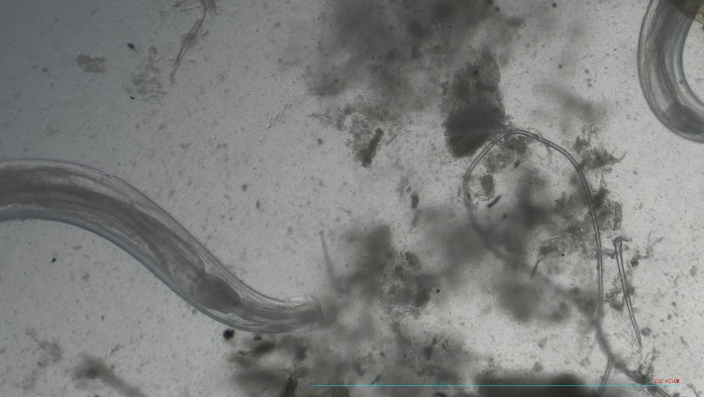
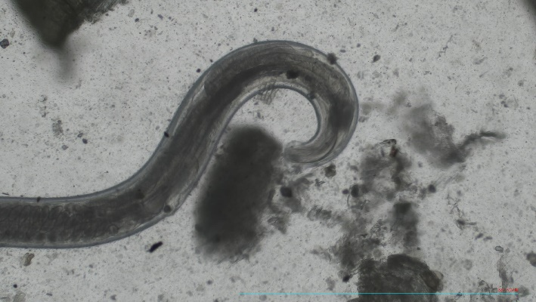

______________________________________________________________________
Dr. Mickey Harlev, Veterinarian Dr. Debora Rapaport, PhD
Israeli Board Certified Manager of Sentinel Diagnostic Laboratory
Head of the Veterinary Service Center Department of Clinical Microbiology and Immunology
Tel Aviv University, Tel Aviv, Israel Faculty of Medical & Health Sciences
Mobile: 972-52-5643396 Tel Aviv University, Tel Aviv, Israel
Office: 972-3-6409919; Fax: 972-6407567 Lab: 972-3-6405137
mickey@tauex.tau.ac.il debirapa@tauex.tau.ac.il
https://med.tau.ac.il/new-veterinary-center52021 https://med.tau.ac.il/sentinel-diagnostic-laboratory

