Tel Aviv, July 10, 2019

The Safety Unit – Sackler Faculty of Medicine

Requirements for Flammable Liquid Storage

Liquid chemicals for molecular biology research use at the Sackler School of Medicine Building are classified as flammable and combustible. To comply with regulations and keep employees safe, the proper storage of these hazardous ensures a safe environment.

Flammable chemicals cannot be stored in hallways or in ordinary lab closets unless the following rules are adhered to:

The Regulations and Standards of the Safety Unit at Tel Aviv University (TAU), flammable liquid chemicals must be stored in flammable liquids storage cabinets such as "Justrite Safety Cabinets" or equivalent ones.

Such cabinets contain a double-wall steel structure with an air space for fire resistance and are appropriate for chemical liquid storage. The cabinet construction protects its contents from fire, preventing the fire from reaching the chemicals.

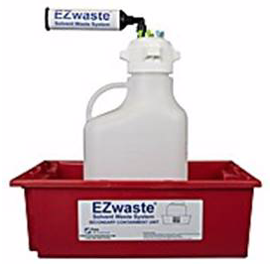
If the safety cabinet is stored in the hallway, it must not block safe passage, allowing for a minimal passage space of 110 cm.

For better safety, and to avoid potential harm, each lab must reduce its liquid chemicals’ stock, starting with proper disposal of bottles past expiry dates. Liquid chemicals must be stored in a flammable liquid storage cabinet with the addition of secondary containments, as shown. In addition, according to TAU Safety Unit regulations, such cabinets should be vented.

Tel Aviv University safety policy is based on Israeli laws (https://safety.tau.ac.il/Safety-in-chem-lab).

Sincerely,

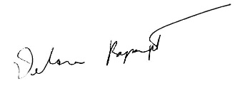
Dr. Debora Rapaport, PhD Dr. Menachem Genut, PhD
Safety Officer – Sackler Faculty of Medicine Chemical Safety Officer – Safety Unit

