Health Monitoring Report in Accordance with FELASA Recommendations

Location: Conventional Medicine TAU Housing: Conventional building Samples collection: 02/06/2024
Species: Mouse sentinel Strain: ICR females Date of report: 09/06/2024
Health report: 9 sentinel mice - FELASA Quarterly

 | Test  method |  | Latest  results | Historical  results
Viruses |  |  | Jun  2024 | Jan  2024 | Jun  2023 | Jan  2023 | Jun  2022 | Jan  2022 | Jun  2021
Mouse hepatitis virus (MHV) | IFA |  | 0/8 | 0/9 | 0/9 | 0/8 | 0/8 | 0/9 | 0/8
Mouse rotavirus (EDIM-ROTA-A) | MFI |  | 0/8 | 0/9 | 0/9 | 0/8 | 0/8 | 0/9 | 0/8
Minute virus of mice (MVM) | MFI |  | 0/8 | 0/9 | 0/9 | 0/8 | 0/8 | 0/9 | 0/8
Mouse parvovirus (MPV-1,-2,-5) | MFI |  | 0/8 | 0/9 | 0/9 | 0/8 | 0/8 | 0/9 | 0/8
Pneumonia virus of mice (PVM) | MFI |  | NT | 0/9 | NT | 0/8 | NT | 0/9 | NT
Sendai virus (SEND) | MFI |  | NT | 0/9 | NT | 0/8 | NT | 0/9 | NT
Theiler’s murine encephalomyelitis virus (TMEV-GDVII) | MFI,IFA |  | 0/8 | 0/9 | 0/9 | 0/8 | 0/8 | 0/9 | 0/8
Ectromelia virus (ECTRO) | MFI |  | NT | 0/9 | NT | 0/8 | NT | 0/9 | NT
Lymphocytic choriomeningitis virus (LCMV) | MFI |  | NT | 0/9 | NT | 0/8 | NT | 0/9 | NT
Mouse adenovirus type 1,2 (FL-MAV-1, K87-MAV-2) | MFI |  | NT | 0/9 | NT | 0/8 | NT | 0/9 | NT
Mouse cytomegalovirus (MCMV) | MFI |  | NT | NT | NT | NT | NT | 0/9 | NT
Reovirus type 3 (REO) | MFI |  | NT | 0/9 | NT | 0/8 | NT | 0/9 | NT
Generic parvovirus (NS-1) | MFI |  | 0/8 | 0/9 | 0/9 | 0/8 | 0/8 | 0/9 | 0/8
Murine norovirus (MNV) | MFI |  | NT | NT* | NT | NT* | NT | NT* | NT
Bacteria, mycoplasma and fungi |  |  | Jun  2024 | Jan  2024 | Jun  2023 | Jan  2023 | Jun  2022 | Jan  2022 | Jun  2021
Mycoplasma pulmonis (MPUL)-Mouse | MFI |  | NT | 0/9 | NT | 0/8 | NT | 0/9 | NT
Bordetella bronchiseptica (Nasopharynx, lung) | CULT |  | 0/8 | 0/9 | 0/9 | 0/8 | 0/8 | 0/9 | 0/8
Citrobacter rodentium (Intestine, feces) | CULT |  | 0/8 | 0/9 | 0/9 | 0/8 | 0/8 | 0/9 | 0/8
Clostridium piliforme (CPIL, Tyzzer’s disease) | MFI |  | NT | 0/9 | NT | 0/8 | NT | 0/9 | NT
Corynebacterium kutcheri (Nasopharynx, lung, intestine) | CULT |  | 0/8 | 0/9 | 0/9 | 0/8 | 0/8 | 0/9 | 0/8
Klebsiella pneumoniae (Naso, lung) | CULT |  | 0/8 | 0/9 | 0/9 | 0/8 | 0/8 | 0/9 | 0/8
Klebsiella oxytoca (Intestine, feces) | CULT |  | 0/8 | 0/9 | 0/9 | 0/8 | 0/8 | 0/9 | 0/8
Pasteurellaceae (Naso, lung)  Pasteurella pneumotropica | CULT |  | 0/8 | 0/9 | 0/9 | 0/8 | 2/8 | 2/9 | 0/8
Pseudomonas aeruginosa (Intestine, Feces) | CULT |  | 0/8 | 0/9 | 0/9 | 0/8 | 0/8 | 0/9 | 0/8
Salmonella spp. (Intestine, feces) | CULT |  | 0/8 | 0/9 | 0/9 | 0/8 | 0/8 | 0/9 | 0/8
Staphylococcus aureus (Skin, naso, lung) | CULT |  | 1/8 | 1/9 | 1/9 | 1/8 | 0/8 | 0/9 | 0/8
Streptococci β-haemolytic (not group D) | CULT |  | 0/8 | 0/9 | 0/9 | 0/8 | 0/8 | 0/9 | 0/8
Streptococcus pneumoniae (Naso, lung) | CULT |  | 0/8 | 0/9 | 0/9 | 0/8 | 0/8 | 0/9 | 0/8
Helicobacter spp. (Intestine, feces) | PCR |  | NT | NT | NT | NT | NT | NT** | NT
Streptobacillus moniliformis (Naso) | CULT |  | 0/8 | 0/9 | 0/9 | 0/8 | 0/8 | 0/9 | 0/8
Dermatophytes (Skin) | CULT |  | 0/8 | 0/9 | 0/9 | 0/8 | 0/8 | 0/9 | 0/8
Corynebacterium bovis (Skin) | CULT |  | 0/9 | 0/9 | 0/9 | 0/8 | 0/8 | 0/9 | 0/8
Pneumocystis carinii (Nude lung) | PCR |  | NT | NT | NT | NT | NT | NT | NT
 |  | Test  method | Latest  results | Historical  results
Parasites |  |  | Jun  2024 | Jan  2024 | Jun  2023 | Jan  2023 | Jun  2022 | Jan  2022 | Jun  2021
Ectoparasites: Fur mites | MICRO |  | 0/8 | 0/9 | 0/9 | 0/8 | 0/8 | 0/9 | 0/8
Endoparasites: Pinworms | MICRO |  | 1/8 | 1/9 | 2/9 | 0/8 | 0/8 | 0/9 | 0/8
Opportunistic protozoa | MICRO |  | 0/8 | 0/9 | 0/9 | 0/8 | 0/8 | 0/9 | 0/8
Nonpathogenic protozoa:  Chilomastix, Entamoeba, Trichomonas | MICRO |  | Present | Present | Present | Present | Present | Present | Present
Pathological lesions | MACRO |  | 1/8 | 1/9 | 0/9 | 0/8 | 0/8 | 0/9 | 0/8
Data are expressed as number positive/number tested
Abbreviations used in this report: ELISA=enzyme linked immunosorbent assay (CR); MICRO=microscopy (TAU); MACRO=macroscopic (TAU); IFA=immunofluorescence assay (CR); MFI=multiplex fluorescent immunoassay (CR); CULT=culture (TAU); PATH=gross pathology (TAU); PCR=polymerase chain reaction (TAU,CR); HIST=histopathology; NT=not tested; TAU=Tel Aviv University Sentinel Diagnostic lab; CR=Charles River lab; IN=result interpreted as non-specific because not confirmed by alternative serologic assay or diagnostic methodology for other serologic assays

Summary
Serology: sentinel mice were negative for all serology tested pathogens.
*We consider mice samples positive for MNV (Murine norovirus).
Bacteriology: One mice sample was positive for Staphylococcus aureus (CM-4, 4th floor). In addition, 5 samples
(CM-10, CM-8, CM-7, CM-6, CM-5) were positive for Proteus mirabilis; one sample (CM-4) was positive for
Enterobacter cloacae. Proteus and Enterobacter pathogens are not included in Felasa panels.
**We consider mice samples positive for Helicobacter spp.
Parasitology: sentinel mice samples were negative for fur mites (ectoparasites) and one sample (CM-10, room 10)
was positive for pinworms (endoparasites). Image attached.
Pathology: One sample (CM-6, room 6) showed cystic ovary.

Notes: Viridans group α-Streptococcus, coagulase negative Staphylococcus sp., Enterococcus sp., Lactobacillus sp., Lactococcus spp. and Escherichia coli are all common components of the microbiota. Trichomonas, Chilomastix and Entamoeba are all common intestinal protozoa.

Identification of Pasteurellaceae:
Pasteurella pneumotropica grows as gray colonies on blood agar whereas “other Pasteurellaceae” refers to yellow lytic colonies. Both are gram-negative and API-20NE-positive (99%). Occasional confirmation by RT-PCR for the ITS region (IDEXX BioResearch) or 16S rRNA PCR and sequencing (Hy Laboratories, IDEXX BioResearch) indicates that gray colonies are Pasteurella pneumotropica (99%, GeneBank accession number: M75083.1, NR_042887.1) and yellow colonies are Pasteurella spp (100%, GeneBank accession number: HF912264, JQ346058). Note that the JQ346058 sequence, called P. pneumotropica, is poorly characterized. It shows 100% identical to a Pasteurella spp (HF912264) [Dafni et al., 2019, J Am Assoc Lab Anim Sci.;58(2):201-207].

Images sample CM-10 pinworms.
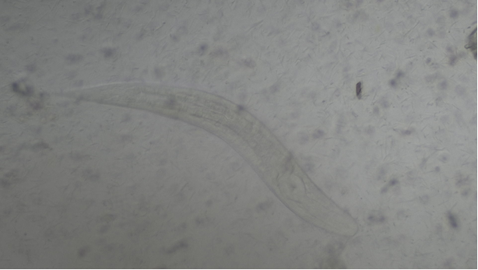
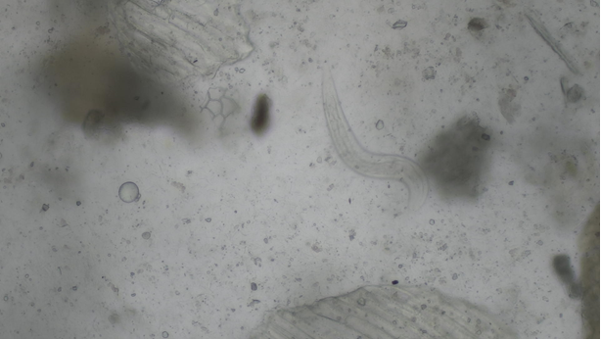

__________________________________________________________________________________________________
Dr. Mickey Harlev, Veterinarian Dr. Debora Rapaport, PhD
Israeli Board Certified Manager of Sentinel Diagnostic Laboratory
Head of the Veterinary Service Center Department of Clinical Microbiology and Immunology
Tel Aviv University, Tel Aviv, Israel Sackler Faculty of Medicine
Mobile: 972-52-5643396 Tel Aviv University, Tel Aviv, Israel
Office: 972-3-6409919; Fax: 972-6407567 Lab: 972-3-6405137; Fax: 972-3-6409160
mickey@tauex.tau.ac.il debirapa@tauex.tau.ac.il
https://med.tau.ac.il/new-veterinary-center52021 https://med.tau.ac.il/sentinel-diagnostic-laboratory

