Health Monitoring Report in Accordance with FELASA Recommendations

Location: Life Sciences TAU Housing: Britannia building Samples collection: 07/07/2024
Species: Mouse sentinel Strain: ICR females Date of report: 16/07/2024
Health report: 4 sentinel mice - FELASA Semiannual. Samples tested: LS-7 (room 7); LS-9 (room 9); LS-19 (room 19); LS-20 (room 20).

 | Test  method |  | Latest  results | Historical  results
Viruses |  |  | Jul  2024 | Jan  2024 | Jul  2023 | Jan  2023 | Jul  2022 | Jan  2022 | Jul  2021 | Jan  2021
Mouse hepatitis virus (MHV) | IFA |  | 0/4 | 1/4 | 0/1 | NT | 1/4 | 1/4 | 0/2 | 0/2
Mouse rotavirus (EDIM-ROTA-A) | MFI |  | 0/4 | 0/4 | 0/1 | NT | 0/4 | 0/4 | 0/2 | 0/2
Minute virus of mice (MVM) | MFI |  | 0/4 | 0/4 | 0/1 | NT | 0/4 | 0/4 | 0/2 | 0/2
Mouse parvovirus (MPV-1,-2,-5) | MFI |  | 0/4 | 0/4 | 0/1 | NT | 0/4 | 0/4 | 0/2 | 0/2
Pneumonia virus of mice (PVM) | MFI |  | NT | 0/4 | NT | NT | NT | 0/4 | NT | 0/2
Sendai virus (SEND) | MFI |  | NT | 0/4 | NT | NT | NT | 0/4 | NT | 0/2
Theiler’s murine encephalomyelitis virus (TMEV-GDVII) | MFI,IFA |  | 0/4 | 0/4 | 0/1 | NT | 0/4 | 0/4 | 0/2 | 0/2
Ectromelia virus (ECTRO) | MFI |  | NT | 0/4 | NT | NT | NT | 0/4 | NT | 0/2
Lymphocytic choriomeningitis virus (LCMV) | MFI |  | NT | 0/4 | NT | NT | NT | 0/4 | NT | 0/2
Mouse adenovirus type 1,2 (FL-MAV-1, K87-MAV-2) | MFI |  | NT | 0/4 | NT | NT | NT | 0/4 | NT | 0/2
Mouse cytomegalovirus (MCMV) | MFI |  | NT | 0/4 | NT | NT | NT | 0/4 | NT | 0/2
Reovirus type 3 (REO) | MFI |  | NT | 0/4 | NT | NT | NT | 0/4 | NT | 0/2
Generic parvovirus (NS-1) | MFI |  | 0/4 | 0/4 | 0/1 | NT | 0/4 | 0/4 | 0/2 | 0/2
Murine norovirus (MNV) | MFI |  | NT* | NT* | 0/1 | NT | 0/4 | NT* | 0/2 | 0/2
Bacteria, mycoplasma and fungi |  |  | Jul  2024 | Jan 2024 | Jul  2023 | Jan  2023 | Jul  2022 | Jan 2022 | Jul  2021 | Jan  2021
Mycoplasma pulmonis (MPUL)-Mouse | MFI |  | NT | 0/4 | NT | NT | NT | 0/4 | NT | NT
Bordetella bronchiseptica (Nasopharynx, lung) | CULT |  | 0/4 | 0/4 | 0/1 | NT | 0/4 | 0/4 | 0/2 | 0/2
Citrobacter rodentium (Intestine, feces) | CULT |  | 0/4 | 0/4 | 0/1 | NT | 0/4 | 0/4 | 0/2 | 0/2
Clostridium piliforme (CPIL, Tyzzer’s disease) | MFI |  | 0/4 | 0/4 | 0/1 | NT | 0/4 | 0/4 | NT | NT
Corynebacterium kutcheri (Nasopharynx, lung, intestine) | CULT |  | 0/4 | 0/4 | 0/1 | NT | 0/4 | 0/4 | 0/2 | 0/2
Klebsiella pneumoniae (Naso, lung) | CULT |  | 0/4 | 0/4 | 0/1 | NT | 0/4 | 0/4 | 0/2 | 0/2
Klebsiella oxytoca (Intestine, feces) | CULT |  | 0/4 | 0/4 | 0/1 | NT | 0/4 | 0/4 | 0/2 | 0/2
Pasteurellaceae (Naso, lung)  Pasteurella pneumotropica | CULT |  | 0/4 | 0/4 | 0/1 | NT | 1/4 | 1/4 | 0/2 | 0/2
Pseudomonas aeruginosa (Intestine, Feces) | CULT |  | 0/4 | 0/4 | 0/1 | NT | 0/4 | 0/4 | 0/2 | 0/2
Salmonella spp. (Intestine, feces) | CULT |  | 0/4 | 0/4 | 0/1 | NT | 0/4 | 0/4 | 0/2 | 0/2
Staphylococcus aureus (Skin, naso, lung) | CULT |  | 1/4 | 0/4 | 0/1 | NT | 0/4 | 0/4 | 0/2 | 0/2
Streptococci β-haemolytic (not group D) | CULT |  | 0/4 | 0/4 | 0/1 | NT | 0/4 | 0/4 | 0/2 | 0/2
Streptococcus pneumoniae (Naso, lung) | CULT |  | 0/4 | 0/4 | 0/1 | NT | 0/4 | 0/4 | 0/2 | 0/2
Helicobacter spp. (Intestine, feces) | PCR |  | NT** | NT** | NT** | NT** | NT** | NT** | NT | NT
Streptobacillus moniliformis (Naso) | CULT |  | 0/4 | 0/4 | 0/1 | NT | 0/4 | 0/4 | 0/2 | 0/2
Dermatophytes (Skin) | CULT |  | 0/4 | 0/4 | 0/1 | NT | 0/4 | 0/4 | 0/2 | 0/2
Corynebacterium bovis (Skin) | CULT |  | 0/4 | 0/4 | 0/1 | NT | 0/4 | 0/4 | 0/2 | 0/2
Pneumocystis carinii (Nude lung) | PCR |  | NT | NT | NT | NT | NT | NT | NT | NT
 |  | Test  method | Latest  results | Historical  results
Parasites |  |  | Jul  2024 | Jan  2024 | Jul  2023 | Jan  2023 | Jul  2022 | Jan  2022 | Jul  2021 | Jan  2021
Ectoparasites: Fur mites | MICRO |  | 0/4 | 0/4 | 0/1 | 1/4 | 0/4 | 0/4 | 0/2 | 0/2
Endoparasites: Pinworms | MICRO |  | 1/4 | 0/4 | 0/1 | 0/4 | 0/4 | 1/4 | 0/2 | 0/2
Opportunistic protozoa | MICRO |  | 0/4 | 0/4 | 0/1 | 0/4 | 0/4 | 0/4 | 0/2 | 0/2
Nonpathogenic protozoa:  Chilomastix, Entamoeba, Trichomonas | MICRO |  | Present | Present | Present | Present | Present | Present | Present | Present
Pathological lesions | MACRO |  | 0/4 | 0/4 | 0/1 | 0/4 | 0/4 | 0/4 | 0/2 | 0/2
Data are expressed as number positive/number tested
Abbreviations used in this report: ELISA=enzyme linked immunosorbent assay (CR); MICRO=microscopy (TAU); MACRO=macroscopic (TAU); IFA=immunofluorescence assay (CR); MFI=multiplex fluorescent immunoassay (TAU); CULT=culture (TAU); PATH=gross pathology (TAU); PCR=polymerase chain reaction (TAU,CR); HIST=histopathology; NT=not tested; TAU=Tel Aviv University lab; CR=Charles River lab; IN=result interpreted as non-specific because not confirmed by alternative serologic assay or diagnostic methodology for other serologic assays

Summary
Serology: sentinel mice sample were negative for all tested Felasa panel pathogens.
*We consider mice samples positive for MNV (Murine norovirus).
Bacteriology: one mice sample (LS-7) was positive for Staphylococcus aureus. Moreover, this sample (LS-7) was
positive for Proteus mirabilis, agent not included in Felasa requirements.
In addition, 3 mice samples (LS-9, LS-19, LS-20) were positive for Proteus vulgaris, also not included
in Felasa requirements.
**We consider mice samples positive for Helicobacter spp.
Parasitology: sentinel mice sample were negative for fur mites (ectoparasites). One sample (LS-20) was positive
for pinworms (endoparasites). Images included.
Pathology: No gross signs.

Notes: Viridans group α-Streptococcus, coagulase negative Staphylococcus sp., Enterococcus sp., Lactobacillus sp., Lactococcus spp. and Escherichia coli are all common components of the microbiota. Trichomonas, Chilomastix and Entamoeba are all common intestinal protozoa.

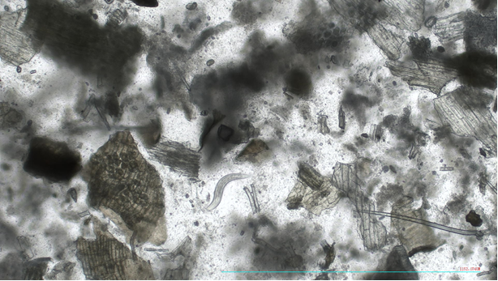
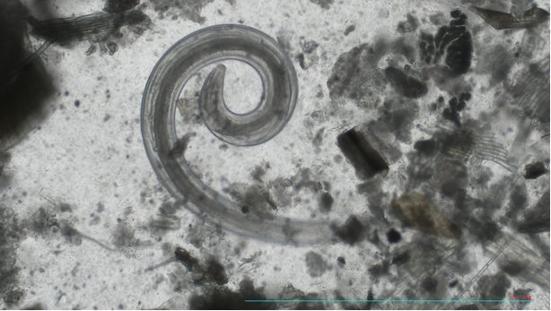
Images: Pinworms in sample LS-20

__________________________________________________________________________________________________
Dr. Mickey Harlev, Veterinarian Dr. Debora Rapaport, PhD
Israeli Board Certified Manager of Sentinel Diagnostic Laboratory
Head of the Veterinary Service Center Department of Clinical Microbiology and Immunology
Tel Aviv University, Tel Aviv, Israel Faculty of Medical & Health Sciences
Mobile: 972-52-5643396 Tel Aviv University, Tel Aviv, Israel
Office: 972-3-6409919; Fax: 972-6407567 Lab: 972-3-6405137
mickey@tauex.tau.ac.il debirapa@tauex.tau.ac.il
https://med.tau.ac.il/new-veterinary-center52021 https://med.tau.ac.il/sentinel-diagnostic-laboratory

